Hi Paypal,

I was donating money to a charity (No Chains for North Korea) that focuses on North Korean issues. Their information can be found below site. They are cited in many newspapers/journals as a legitimate organization.

<https://www.facebook.com/NKNoChain>

[https://www.facebook.com/microsdcardsnorthkorea/](https://urldefense.proofpoint.com/v2/url?u=https-3A__www.facebook.com_microsdcardsnorthkorea_&d=DwMFaQ&c=j-EkbjBYwkAB4f8ZbVn1Fw&r=6IQ9qzVRGrqAQDAAf2ykb62l5QfapfERS5pH5E_VXYs&m=t7BdXr02uTlSDqgGTxyZnbh1ElV6tlTlOG-Q8KbhjNE&s=06X7pST0TwDSZ3OUsWDw6VJxgpafyGqR0MWT1nTc9i8&e=)

News Articles:

<http://www.cnn.com/2016/05/25/asia/north-korea-drones/index.html>

http://weldbham.com/blog/2017/03/13/north-korean-defector-speaks/

The charity is running the below Champaign, which I was donating too. There is no financial transaction or trade of good as you can see below.

Please see the below screenshot of the charity that I was donating too.

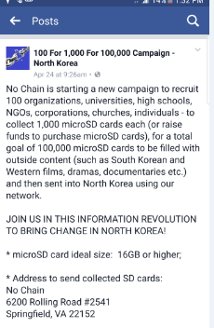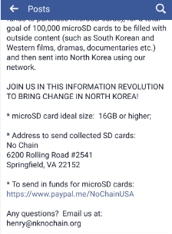

If you have any questions about the organization, please contact Henry Sung at [henry@nknochain.org](mailto:henry@nknochain.org)

Please contact me also if you need more evidence on this transaction

Vicki Bergquist - 9403959884